**PART: I**

1. Time Spent (3 hours)

a. ans:

Snowflake diagram:

Big-University

Fact table

|  |
| --- |
| student_id |
| course_id |
| semester_id |
| Instructor_id |
| count |
| Avg_grade |

Student

Dimension table

|  |
| --- |
| student_id |
| Student_name |
| Address_id |
| Major |
| status |
| university |

Course

Dimension table

|  |
| --- |
| Course_id |
| course_name |
| department |



Address

Dimension table

|  |
| --- |
| Address_id |
| street |
| city |
| state |
| Zip_code |
| country |

Instructor

Dimension table

|  |
| --- |
| instructor_id |
| Inst_name |
| Department |

Semester

Dimension table

|  |
| --- |
| semester_id |
| Semester_name |
| year |

b. Ans:

* Roll-up on course from course_id to department
* Roll-up on student from student_id to university
* Dice on course, student with department= “CS” and university = “big-university”
* Drill-down on student from university to student_name

c. Ans:

Li = 5 -1 = 4

Where, N = 4 dimensions

Hence, this cube will have (Li + 1) ^4 = 625 cuboids

2.

a. Ans:Assuming each dimension has only one level, draw the complete lattice of the cube.

all

0 -D cuboid

1 – D cuboid

2 – D cuboid

3 – D cuboid

A B

C

A, B A, C B, C

A, B, C

b. Ans:

|  |  |
| --- | --- |
| Apex (*4 bytes) | All: 1 * 4 = 4 |
| 1 – D Cuboids | A: 100, 000 * 4 = 400, 000  B: 100 * 4 = 400  C: 1000 * 4 = 4,000 |
| 2 – D Cuboids | AB: 100,000 * 100 * 4 = 40,000,000  AC: 100, 000 * 1,000 * 4 = 400,000,000  BC: 100 * 1000 * 4 = 400,000 |
| Base | ABC: 100,000 * 100 * 1000 * 4= 40,000,000,000 |
| Total (in bytes) | 40440804404 |

c. Ans:

1 – D cuboid

2 – D cuboid

3 – D cuboid

all

A B

C

A, B A, C B, C

A, B, C

The total amount of main memory space required for computing the 2-D planes is

1,000 x 100 (for the entire BC plane) + 100,000 x 100 (for one row of the AB plane) + 100,000 x 1000 (for one chunk of the AC plane) = 100,000 = 10^5

+ 10,000,000 = 10^7

+ 100,000,000 = 10^8

110,100,000 (cells) ≈10 ^8

Since each cell takes 4 bytes, this corresponds to a total of

110,100,000 * 4 = **440,400,000** bytes ≈ **0.4404** GB bytes

**PART: II**

3. Time Spent( 24 hours)

Lesson 1:

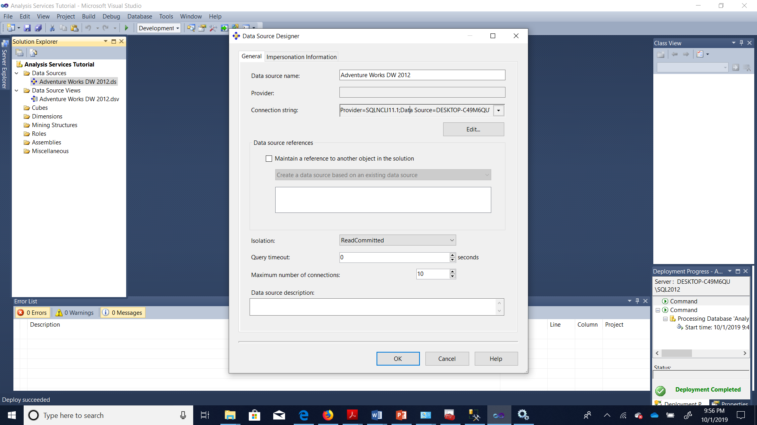

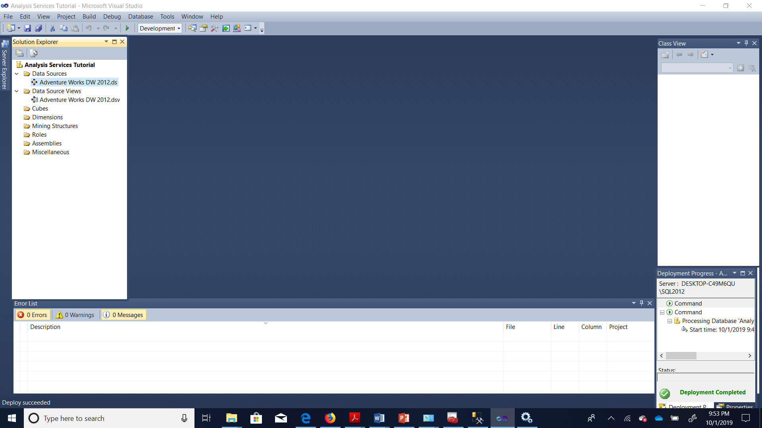

**Lesson 2:**

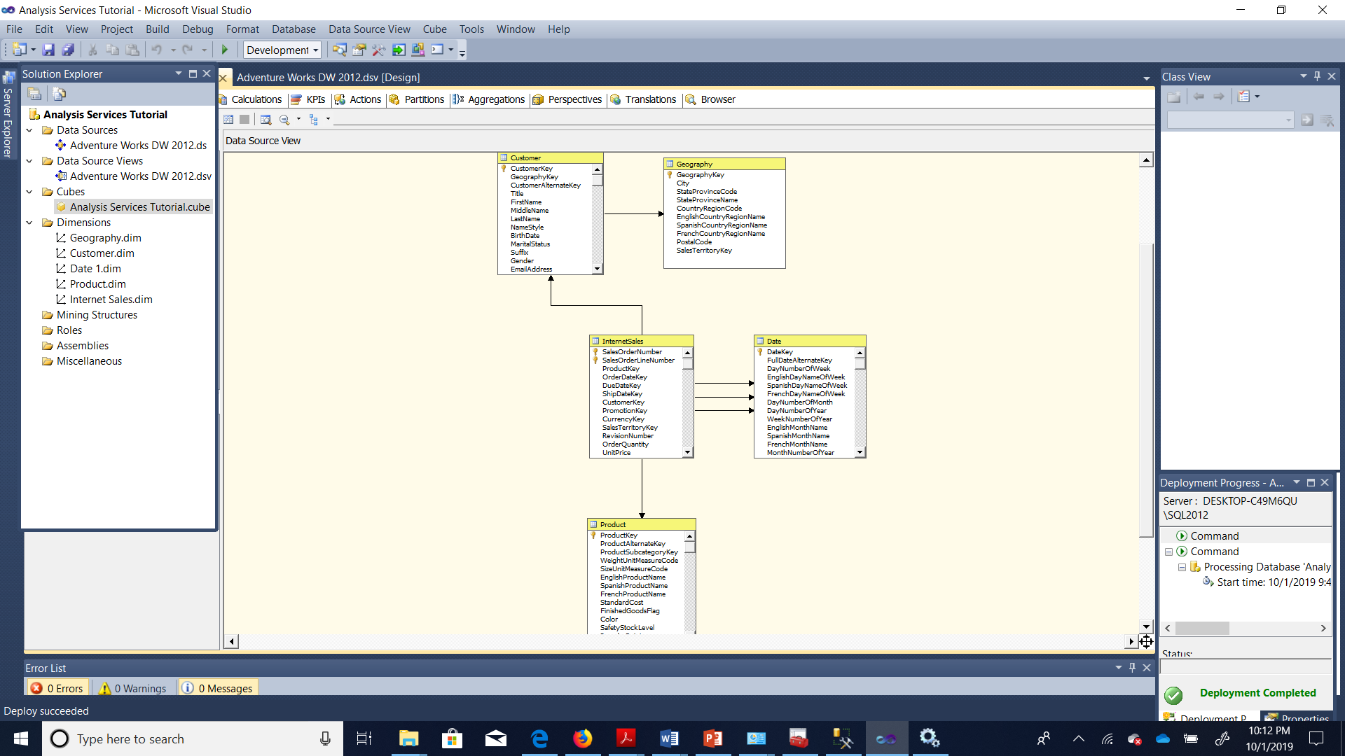

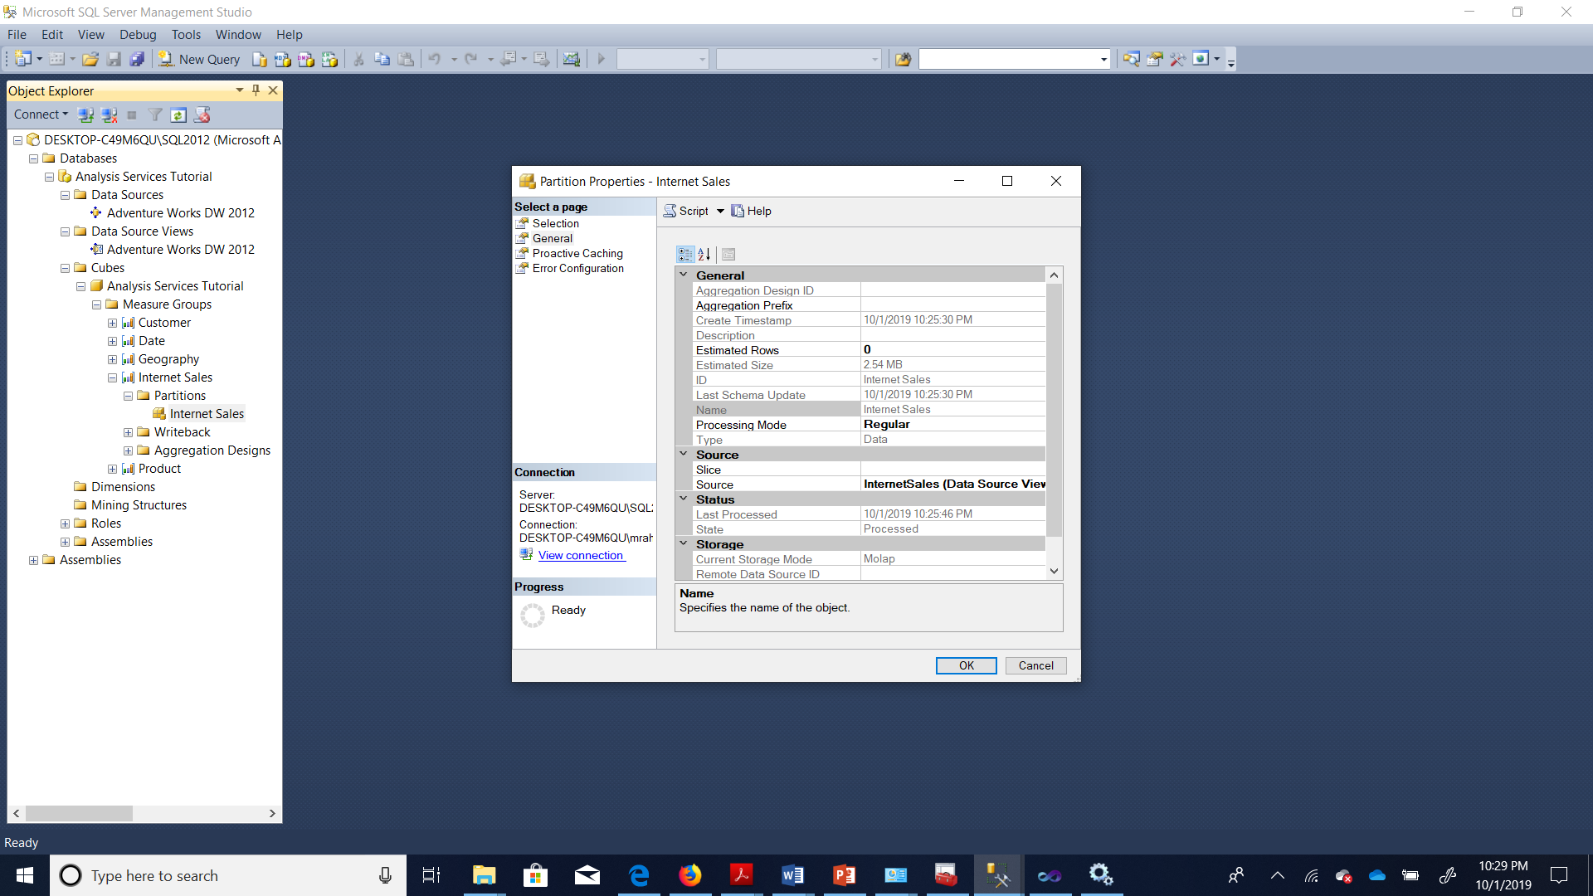

Lesson 3:

